**FUNCTIONAL AND TECHNICAL COMBINED DOCUMENTATION**

**Page (31): WatchList--Fixed Income (Front End Url:** http://localhost:8100/page31/Page31)

**Functional Picture:**

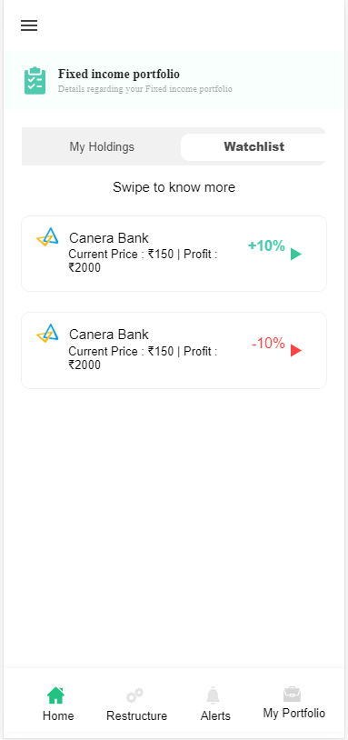

**In this Page, the user is going to see the list of Fixed Income securities that the user has added in his portfolio.**

**Technical Explanation (Front End and Back End):**

**In Page31.tsx, we are calling following 1 API:**

1. WatchListAPIFI: see backend python file. In this we are doing GET requests.

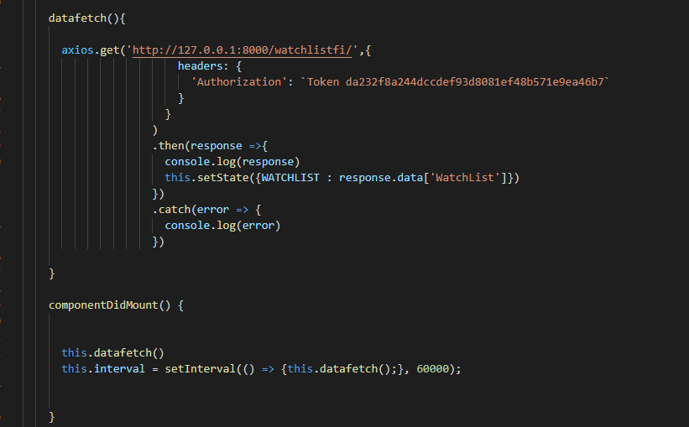

**As you can see, we are calling the** WatchListAPIFI

**using this url:** [**http://127.0.0.1:8000/watchlistfi/**](http://127.0.0.1:8000/watchlistfi/)**. In this we are taking the Fixed Income data to populate Fixed Income Securities on the front end.**

**Kindly see the given below backend Code for this GET request.**

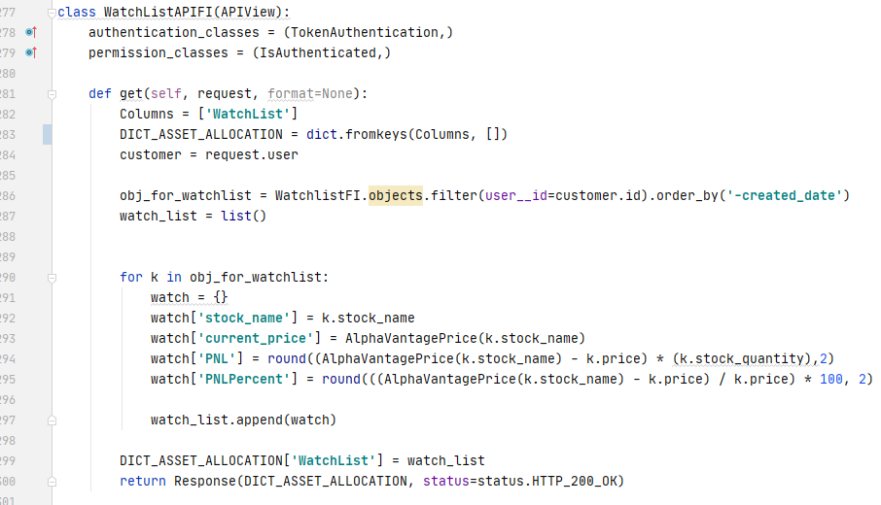

**The Above API is taking the data from the Fixed Income Database throwing the data on the front end through Response.**

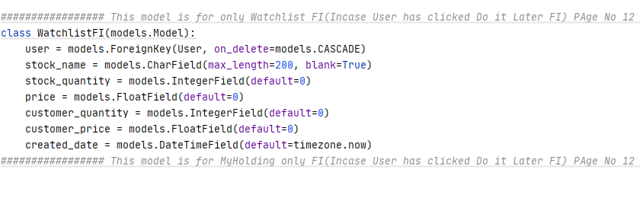

**DONE!!!**